**Name: Ayush Patra**

**Roll No: TIT2425043**

**PRACTICAL 7:-**

The file Iris.csv contains 50 samples from each of 3 species of Iris (Iris setosa,Iris virginica,Iris versicolor). Build DBScan clustering Model and plot it.

iris<- read.csv("Iris.csv")

install.packages("fpc")

library("fpc")

iris_1<- iris[-5]

Dbscan_cl <-dbscan(iris_1, eps=0.45,MinPts = 5)

Dbscan_cl

Dbscan_cl$cluster

plot(Dbscan_cl,iris_1,main="DbScan")

**OUTPUT:**

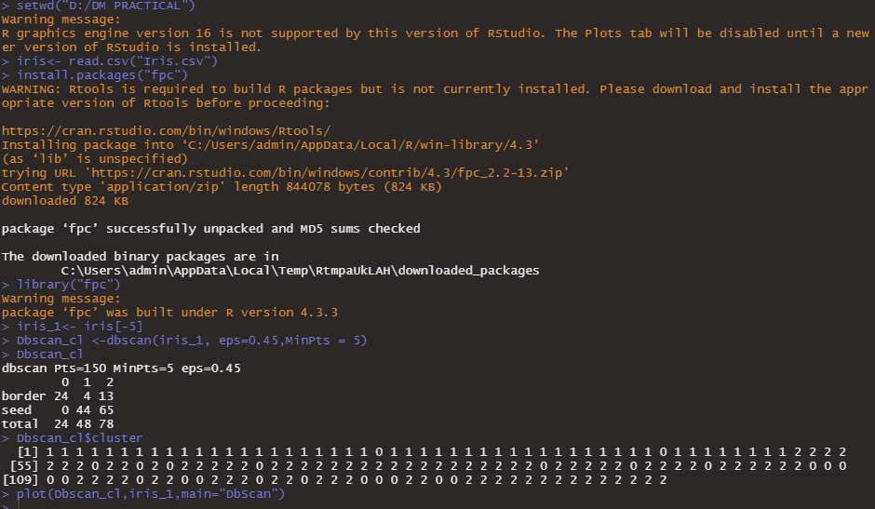

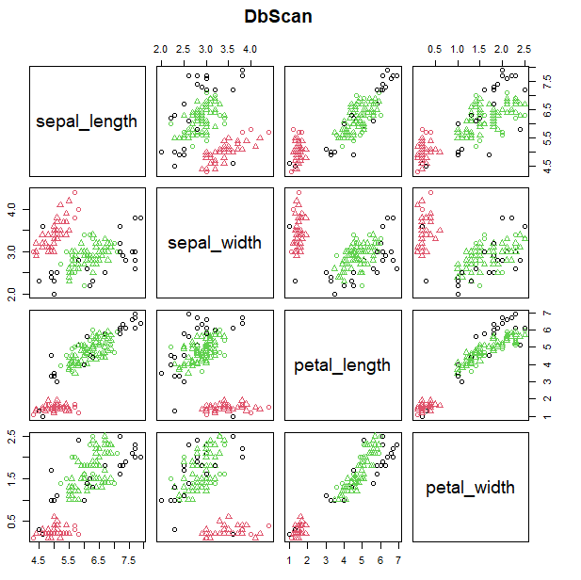

**PRACTICAL 8:- Hierarchical Clustering**

**mtcars**(motor trend car road test) comprises fuel consumption, performance and 10 aspects of automobile design for 32 automobiles. Perform hierarchical clustering and plot the dendrogram and cut the tree by the no. of clusters.

Ans.

mtcars.df<-read.csv("mtcars.csv")

mtcars

library("dplyr")

library("ggplot2")

#finding distance matrix

distance_mat <- dist(mtcars,method='euclidean')

distance_mat

#finding hierarchical clustering model to training dataset

hierar_cl <-hclust(distance_mat,method="average")

hierar_cl

plot(hierar_cl)

abline(h=200,col="green")

fit=cutree(hierar_cl,k=3)

fit

table(fit)

rect.hclust(hierar_cl,k=3,border="red")

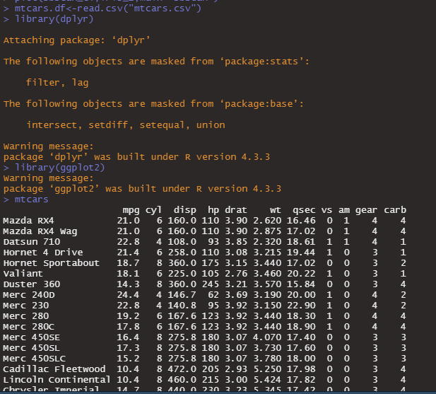

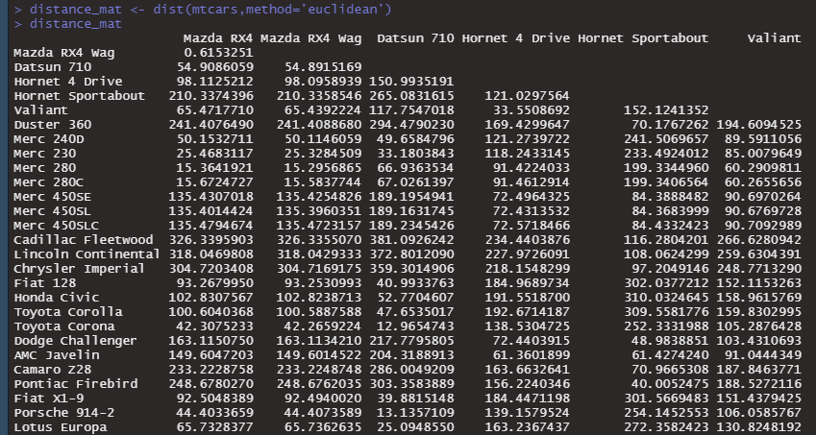

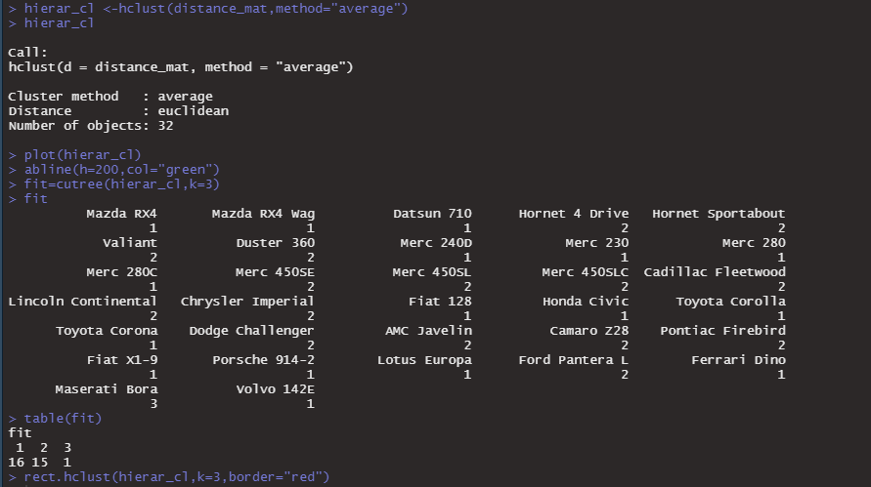

#plotting hierarchy cluster

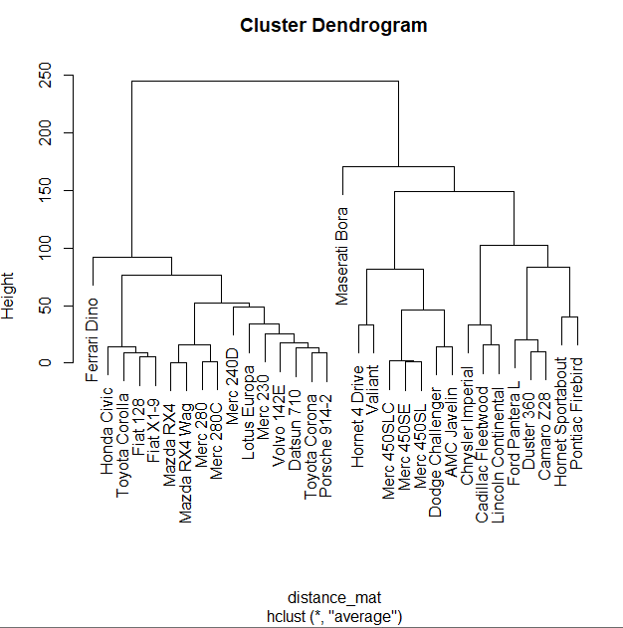

#abline for green line

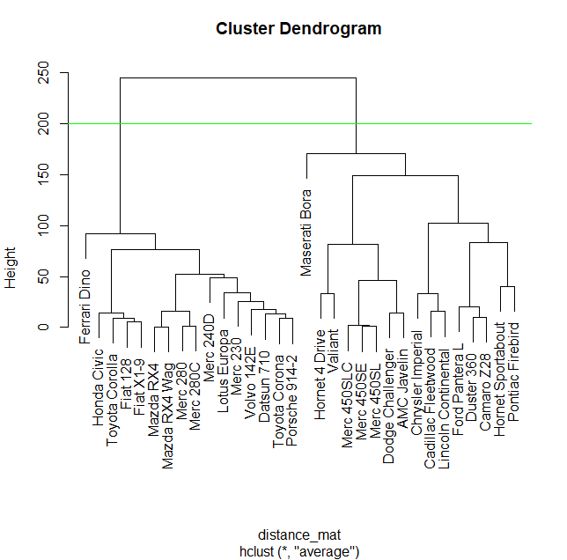

#Three cluster with red border (highlight cluster by drawing rectangle)

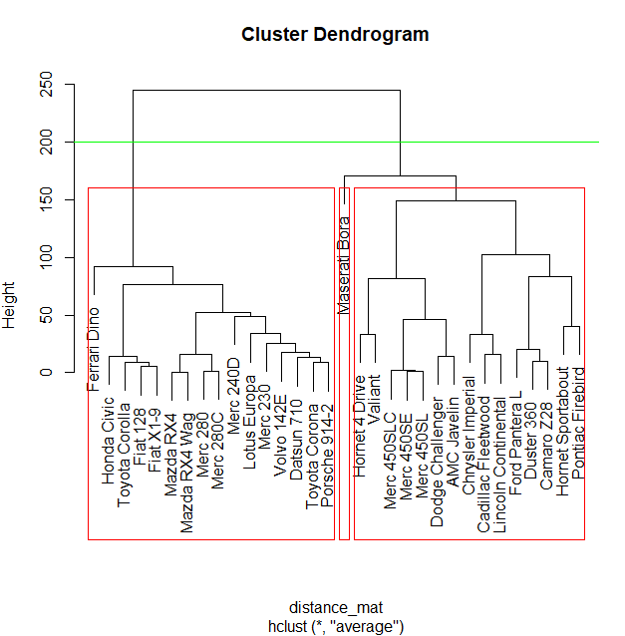

DESCRIPTION OF THE DATASET

A data frame with 32 observations on 11 (numeric) variables.

1. mpg - Miles/(US) gallon

2. cyl – Number of cylinders

3. disp – Displacement (cubic inches)

4. hp – Gross horsepower

5. drat – rear axle ratio

6. wt – Weight (1000 lbs)

7. qsec – ¼ mile time

8. vs - Engine(0 = V-shaped, 1 = straight)

9. am – Transmission (0 = automatic, 1 = manual)

10. gear – Number of forward gears

11. carb – Number of carburetors